BLOCK PROFILE 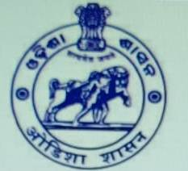
OF CHC,AUL FOR THE YEAR -2023-24 ON DATE-07-02-2024.

BLOCK-CHC,AUL
DIST-KENDRAPARA
STATE-ODISHA
PIN-754219

OPD-CHC,AUL matru sadana

Herbal garden garden

Parking Flag-post

Rks-meeting IPD & Dressing Room

Stress management at – chc aul

Pest control

Cleaness drive by ngo

Monthly meeting at- cha,aul

